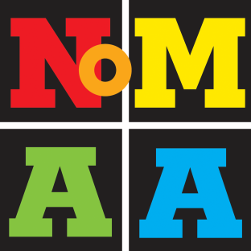
Uptown Arts Review 2016
Submission Form

Submission deadline (extended): Sunday 24 April 2016, 11:59 p.m. EDT

Exhibition: 6–30 June 2016, Rio II Gallery, 583 Riverside Drive, New York, NY 10031

Presented by the Northern Manhattan Arts Alliance (NoMAA) in partnership with Broadway Housing Communities and The Sugar Hill Children’s Museum of Art and Storytelling.

1. CONTACT INFORMATION

Artist name:

Mailing address:

Telephone: E-mail:

Website (if any):

Facebook (if any): Twitter (if any):

2. ARTIST STATEMENT
One-paragraph statement commenting on the subject, process and/or any other pertinent information about the work submitted (100 words maximum):

3. IMAGE LIST (please fill this form):

 | Artist name | Title of work | Year | Media | Dimensions  (width x height) | Price | E-mail
1)
2)
3)
4)

4. ARTIST BIO / RÉSUMÉ: Please e-mail a one-page résumé in Word, labeled with artist name and type of document, e.g., “Smith_Jane_Resume.doc”

5. FOUR DIGITAL IMAGES: Please e-mail up to four (4) images, formatted as JPG, 300 dpi, 4” wide (on largest side), max 1MB each. Label each image as follows: “LastName_FirstName_Title_Year_Media_Dimensions.jpg” (e.g., Smith_John_Cityscape_2015_Oil on canvas_12x12.jpg)

E-mail submission: Please send ONE e-mail containing this completed submission form (add your name to the filename, e.g., “Smith_Jane_UptownArtsReview_2016_SubmissionForm.docx”), résumé and images to nomaagallery[at]gmail.com.

