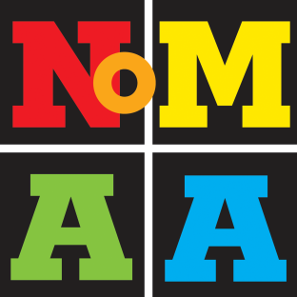 | CALL FOR WOMEN ARTISTS!  Women in the Heights: Transitions  SUBMISSION FORM

1. CONTACT INFORMATION
A) Artist name:
B) Mailing address:
C) Telephone:
D) E-mail:
E) Website (if applicable):

2. ARTIST STATEMENT: One-paragraph statement commenting on the subject, process and/or any other pertinent information about the work submitted (100 words maximum):

3. IMAGE LIST: Please fill this form:

 | First Name | Last Name | Title | Year | Media | Price
e.g. | Rosa | Smith | Women in Blue | 2015 | Acrylic on canvas | $500
1.
2.
3.
4.

4. ARTIST BIO / RESUME: Please email a 1-page resume in Word or PDF, labeled with artist last name and type of document (i.e., “Smith_Resume.doc” or “Smith_Resume.pdf”).

5. FOUR DIGITAL IMAGES: Please email up to 4 images, formatted as JPG, 300 dpi, 4” wide (on largest side), max 1MB each. Label each image as follows: “LastName_Image#_Title_Media_Size.jpg” (e.g., Smith_1_Woman in Blue_Acrylic on canvas_30x40.jpg, Smith_2_Woman in Red_Acrylic on canvas_30x40.jpg).
Media/Video works must be submitted as links to youtube.

Email submissions (one email containing this completed submission form, resume and images) to: nomaagallery@gmail.com.

